

**EAST WEST BANCORP, INC.**

**Model Risk Management**

**Model** **Inherent Risk Rating Assessment Form**

**(MRM-Control02)**

**Version: v04**

# The Model Inherent Risk Rating (Model-IRR) Assessment Questionnaire

|  |  |  |  |
| --- | --- | --- | --- |
| **Model Name** | Alipay (Model ID: 059) | | |
| **Model Owner** | Charles Lin | | |
| **Assessment Completion Date** | 2024/08/06 | | |
| **Model Category** | Please choose one or many from the following – Credit Risk Models, Market Risk Models, Liquidity Risk Models; Regulatory Models, Financial Reporting Models, Capital Models, Other Models; First Line Models  *\*The Model Category is defined based on the risk type that the model is designed to address (Please refer to below Appendix 2 for detail). The risk type definition is documented in the Bank’s ERM policy (available via the Bank’s BridgeNet). For example, credit risk models are designed to mitigate credit risk for the Bank. The Model Category is used to evaluate Model Materiality in this Model Inherent Risk Rating assessment process. When the model under evaluation cannot be easily categorized as one the of listed model categories and belongs to the First Line business, we categorize it as the First Line Models.*  **Model Owner Response**:    First Line Model | | |
| **Model Materiality Value** | * Provide **Gross Notional Amount of the Model Portfolio*(s)** IF your model is Credit Risk Models, Market Risk Models, Liquidity Risk Models   *Model Portfolios - Portfolios the model applies to.   * Provide **Gross Exposure Amounts on Balance Sheet** IF your model is Regulatory Models, Financial Reporting Models, Capital Models, Other Models * Provide **Gross Exposure Amounts on Balance Sheet or Frequency and Number of Decisions Taken** IF your model is First Line Models   **Model Owner Response**:    The bank offers Alipay, a real time foreign exchange transfer remittance process available to customers enrolled Digital Banking. As of March 31, 2024, there were 242,387 active customers using Digital Banking, aggregate deposit account portfolio balance of $15,113,592,594. | | |
| **Model Materiality Thresholds** | * **Above** model materiality threshold when $Model Materiality Value÷Total Assets≥5\%$* **Below** model materiality threshold when $Model Materiality Value÷Total Assets<5\%$  Please conduct the calculation and provide your response.  **Model Owner Response**:    Above model materiality as the aggregate portfolio balance is greater than 5% of the total assets $70.876 billion as of March 31, 2024, based on the published EWBC 1Q 2024 earnings release. | | |
| **Model-IRR** | ***To Be Finalized by MRM*** | | |
| **Process Steps** | **Model-IRR Assessment Category** | **Assessment Instruction** | **YES/NO & Rationale** |
| **STEP 1** | **MODEL PURPOSE** – Does the model provide outcome to any of the following?   * Financial Statements * Regulatory Reporting * Compliance Requirements * Critical Management Decision | **YES** – Go to **STEP 4**  **NO** – Go to **STEP 2** | ***Instruction:*** *Model Owner to provide detailed rationales to support the Yes or No decision here.*  **Model Owner**:  No, the Bank’s implementation of Alipay is a  managed solution, meaning Ant Group controls mobile and online payment and is responsible for the fraud detection. Ant Group has its own risk management detection model leverages machine learning to uncover fraud with anomaly detection to identify transactions that deviate from the expected patterns and to identify groups of individuals that are collaborating to commit financial fraud.  **MRM**: No additional comment. |
| **STEP 2** | **MODEL USE** – Is the model used to calculate any of the following?   * Risk * Price * Value | **YES** – Go to **STEP 3**  **NO** – Go to **STEP 5** **A** | ***Instruction:*** *Model Owner to provide detailed rationales to support the Yes or No decision here.*  **Model Owner**:    Yes, the vendor owned model designed to detect fraudulent remittance activities  **MRM**: No additional comment. |
| **STEP 3** | **MATERIALITY\*** – Does the model exceed materiality threshold? ***Note*** that the **denominator** should be Total Assets ($ as of mm/dd/yyyy). However, where the Notional Amount is not suitable for evaluating the model’s materiality, other measures can/should be used with explanation in the assessment.     * Use **Gross Notional Amount of the Model Portfolios** for: * Credit Risk Models * Market Risk Models * Liquidity Risk Models * Use **Gross Exposure Amount on Balance Sheet** for: * Regulatory Models * Financial Reporting Models * Capital Models * Other Models * Use **Gross Exposure Amount on Balance Sheet or Frequency & Number of Decision Taken** for: * First Line Models * If the above suggestions are not suitable for your assessment, please use other measures that you see appropriate—Please provide detailed description and rationale. | **YES** – If >= 5%, Go to **STEP 5** **B**  **NO** – If < 5%, Go to **STEP 5** **A** | ***Instruction:*** *Model Owner to provide detailed rationales to support the Yes or No decision here.* ***Note*** *that the* ***denominator*** *should be Total Assets ($ as of mm/dd/yyyy). However, where the Notional Amount is not suitable for evaluating the model’s materiality, other measures can/should be used with explanation in the assessment.*  **Model Owner**:  Yes, $15,113 billion / $70,876 billion total assets = 21 %  **MRM**: No additional comment. |
| **STEP 4** | **MATERIALITY\*** – Does the model exceed materiality threshold? Note that the **denominator** should be Total Assets ($ as of mm/dd/yyyy).   * Use **Gross Notional Amount of the Model Portfolios** for: * Credit Risk Models * Market Risk Models * Liquidity Risk Models * Use **Gross Exposure Amount on Balance Sheet** for: * Regulatory Models * Financial Reporting Models * Capital Models * Other Models * Use **Gross Exposure Amount on Balance Sheet or Frequency & Number of Decision Taken** for: * First Line Models | **YES** – If >= 5%, Go to **STEP 5** **C**  **NO** – If < 5%, Go to **STEP 5** **B** | *Instruction: Model Owner to provide detailed rationales to support the Yes or No decision here.*  **Model Owner**:  Skip per Model-IRR Assessment responses from step 1 to 3 |
| **STEP 5** | **Preliminary Model Inherent Risk Rating Assigned:**   1. **LOW** 2. **MODERATE** 3. **HIGH** | 1. **LOW** or 2. **MODERATE** or 3. **HIGH** | *Instruction: Model Owner to provide summary rationales to support the rating here.*  **Model Owner**:  Moderate based on the step 3 model materiality response  **MRM**: No additional comment. |
| **STEP 6** | **Expert & Management Overlay**   * Adjustments made to the Preliminary Model-IRR in **Step 5** is based on consideration of other material risk factors that cannot be captured in the **Model Use**, **Model Purpose** and **Model Materiality**. The material risk factors could be (but not limited to): * Model Quality * Model Interdependencies * Reputation Risk * Model Production Platform * Model Production Implementation * Model User Resource Limitations * Other Risks Unique to the Model   If the **Model Owner overrides Step 5 Preliminary Model-IRR**, please provide adequate rationales to justify the Rating Change. Rationales need to clearly link with relevant risk factors associate with the model | * **Model Owner**’s Assessment of Model-IRR:  1. **LOW** or 2. **MODERATE** or 3. **HIGH** | *Instruction: Model Owner to provide detailed justification for Model-IRR Change*  **Model Owner**:  No management overrides.  **MRM**: No additional comment. Final IRR as Moderate. |

*\*Please Note: The* ***Model Materiality Assessment Criteria*** *in both steps (3 & 4) are the same. It is designed as such to carry out the decision tree logic.*

**Below please find supplemental information MRM would like to share with your team regarding the Model Inherent Risk Rating Assessment process. Please note that these are for your information only.**

# Appendix 1. Overview of Model Inherent Risk Rating Assessment

The **Model Inherent Risk Rating (“Model-IRR”)** determines the frequency and rigor of the model’s baseline validation and periodic revalidations, assists in prioritizing model validation resources, and affects certain other Policy requirements.

The Model-IRR Assessment Process (MRM-Control02) described in this document is to support the Model Owners in the effort of analyzing Model Inherent Risk. It is intended to establish operating process and standard guidelines to fulfill actions necessary to execute and support requirements outlined in the Model Risk Management (“MRM”) Policy (MRM-PnP01) and Procedures (MRM-PnP02). Instructions and guidelines in this document are applicable to and required for all East West Bancorp, Inc., East West Bank (U.S.), Hong Kong, and China’s (collectively, “EWB” or “Bank”) quantitative processes.

This Model-IRR Assessment Process supports the enterprise-wide MRM Framework and is not intended to replace any entity procedures (e.g., the Greater China).

# Appendix 2. The Model Inherent Risk Rating Assessment (CONTROL 2) Methodology

## The Model-IRR Assessment Categories

The Model-IRR assessment process consists of 1) Decision tree-based process and 2) Management/expert overlay.

1. Decision tree-based process consists of:

* **Model Use** and **Model Purpose** Evaluation – Assess the criticality of the model results to the business process
* **Model Materiality** Evaluation – Provides a general approximation of the model’s financial impact to the Bank if the model fails to operate as intended; Determined based on:
* Model Use Category
* Model Material Value
* Model Materiality Thresholds
* Critical Management Decision

1. The **Management/Expert Overlay** represents adjustments made to the preliminary decision tree-based Model-IRR outcome after the consideration of other material risk factors that cannot be captured in the Model Use, Model Purpose, and Model Materiality categories, such as (but not limited to):

* Model Quality
* Model Interdependencies
* Reputation Risk
* Model Platform/Implementation
* Model User Resource Limitations
* Other Risks Unique to the Model

## The Decision Tree and Assessment Criteria

1. **Model-IRR Assessment Criteria**

The **Model Materiality** value is determined by the Model Use category.

|  |  |
| --- | --- |
| **Model Category\*** | **Model Materiality Value** |
| Credit Risk Models  Market Risk Models  Liquidity Risk Models | Gross Notional Amount of the Model Portfolio*(s)  *Model Portfolios – Portfolios the model applies to. |
| Regulatory Models  Financial Reporting Models  Capital Models  Other Models | Gross Exposure Amounts on Balance Sheet |
| First Line Models | Gross Exposure Amounts on Balance Sheet or Frequency and Number of Decisions Taken |

***Please note:***

* *The Model Category is defined based on the risk type that the model is designed to address. The risk type definition is documented in the Bank’s ERM policy (available via the Bank’s BridgeNet). For example, credit risk models are designed to mitigate credit risk for the Bank.*
* *The Model Owner may consider the model impact to both the Balance Sheet and Income Statement as appropriate. As Notional Amounts are used for both SEC Disclosure and Call Report purposes, the Model Owner may consider the Carrying Amounts on the Balance Sheet.* *Where the Notional Amount is not suitable for evaluating the model’s materiality, other measures can/should be used with explanation in the assessment.*
* *The above model category is used to evaluate Model Materiality in this Model Inherent Risk Rating assessment process. When the model under evaluation cannot be easily categorized as one the of above model categories and belongs to the First Line business, we categorize it as the First Line Models.*

**Materiality Thresholds**

|  |  |
| --- | --- |
| **Above Materiality Threshold** | **Below Materiality Threshold** |
| >= 5% of Total Asset | < 5% of Total Asset |

**Model-IRR Assessment Category & Description**

|  |  |  |
| --- | --- | --- |
| **#** | **Model-IRR Categories** | **Description** |
| **1** | **Model Use** | * Evaluate the criticality of the model results to the business process. |
| **2** | **Model Purpose** |
| **3** | **Model Materiality** | * Evaluate a general approximation of the financial impact of the model to the Bank if the model fails to operate as intended. * Determined based on: * Model Use Category. * Model Material Value. * Model Materiality Thresholds. * Critical Management Decision. |
| **4** | **Expert & Management Overlay** | * Adjustments made to the Preliminary Model-IRR based on consideration of other material risk factors that cannot be captured in the Model Use, Model Purpose and Model Materiality. The material risk factors could be (but not limited to): * Model Quality. * Model Interdependencies. * Reputation Risk. * Model Production Platform. * Model Production Implementation. * Model User Resource Limitations. * Other Risks Unique to the Model. * The Model Risk Management (“MRM”) is required to sufficiently document the Expert & Management Override of the Preliminary Model-IRR rationales to justify the rating change. Rationales need to clearly link with relevant risk factors associate with the model |

1. **Model-IRR Assessment Process**

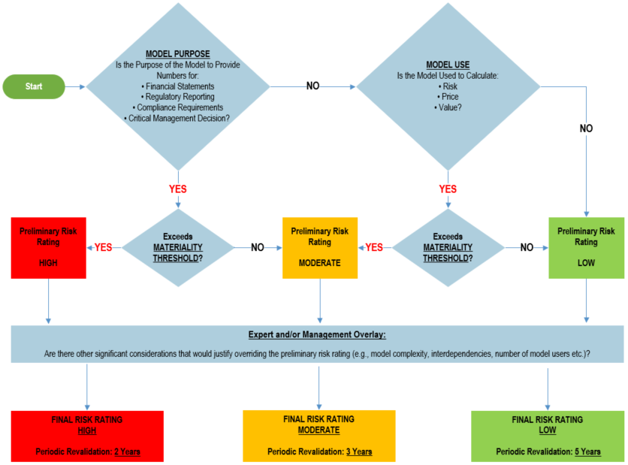

## The Model-IRR Assessment Steps

Steps used for Model-IRR assessment are:

* **Step 1:** Model Owners perform the Model-IRR assessment using this assessment form and submit it to MRM for evaluation. Please refer for MRM Policy (MRM-PnP01) and MRM Procedures (MRM-PnP02) for additional information regarding this task.
* **Step 2:** The MRM group will review submitted information and viewpoints of the Model Owner before making final determination. MRM will communicate with the Model Owner regarding the final Model-IRR assignment to ensure clear communication and agreement.
* **Step 3:** The MRM group will document the final Model-IRR information in the MRM Model Inventory and assign appropriate independent model validation schedule.

# Appendix 3. Overview of the MRM Framework

The MRM Framework is comprised of the 11-controls for managing model risk at the Bank. These controls align with various stages of a model’s end-to-end lifecycle. The Model-IRR Assessment Process addresses **Control 2: Model Inherent Risk Rating**.

**End-to-End Model Lifecycle and Model Risk Management Framework**

**Model Life Cycle**

**Model Risk Management Framework Controls**

**CONTROL 9**

**Ongoing Model Performance & Risk Monitoring**

**CONTROL 10**

**Model Change Management**

**CONTROL 8**

**Model Production Usage**

**CONTROL 6**

**Independent Model Validation**

**CONTROL 7**

**Model Approval for Production**

**CONTROL 1**

**Model Identification & Enterprise-wide Model Inventory**

**CONTROL 2**

**Model Inherent Risk Rating**

**CONTROL 3**

**Model Development**

**CONTROL 4**

**Model Production Implementation**

**CONTROL 5**

**Model Methodology, Production Implementation & Data Quality Assessment Documentation**

**CONTROL 11**

**Model Governance (Policy, Procedures, Guidelines and Templates) & Risk Reporting**

# MRM Control 2 Assessment Form Change Log

***Please Note:*** *This assessment form will only be revised when needed. However, the form is being evaluated when is in use for potential enhancement.*

|  |  |  |  |  |
| --- | --- | --- | --- | --- |
| **#** | **Doc. Version** | **High Level Change Description** | **Doc. Change Date** | **Section Changed** |
| 1 | v01 | First version | 10/31/2018 | All |
| 2 | v02 | Minor enhancement | 09/03/2020 | Throughout |
| 3 | V03 | Changed the material threshold from 2.5% to 5% | 10/06/2022 | Throughout |
| 4 | V04 | Re-ordered the assessment form | 01/17/2023 | Throughout |
|  |  |  |  |  |
|  |  |  |  |  |